**Lab 2: Documenting a Workstation Configuration Using Common Forensic Tools**

**By**

**Natnael Kebede**



**University of Dallas**

**2020**

This Paper Submitted in Partial Fulfillment of the Requirements for

CYBS 7359 – Penetration Testing and Vulnerability Assessment

Spring 2020

Presented to Dr. Renita Murimi

**Section 1**

1. Make a screen capture showing the System Overview and paste it into the Lab Report file.

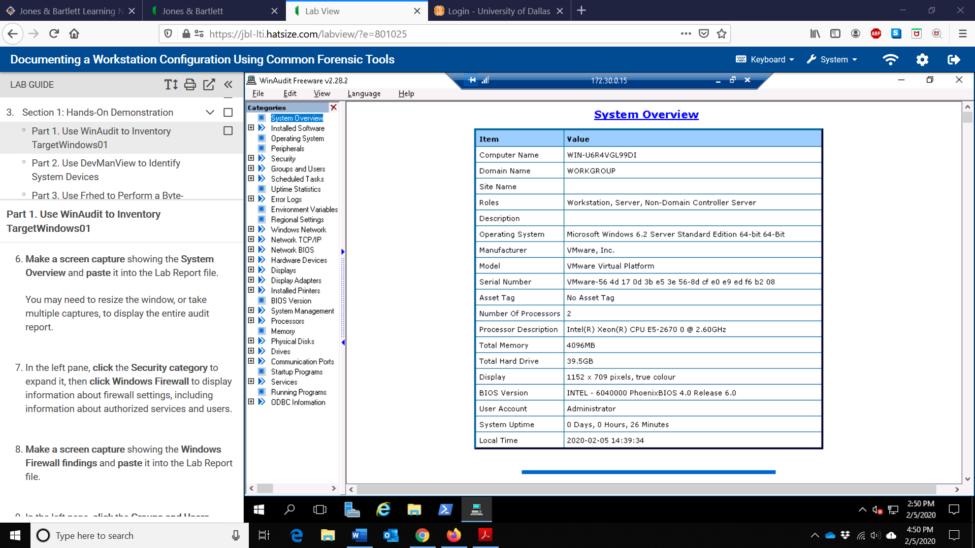

1. Make a screen capture showing the Windows Firewall findings and paste it into the Lab Report file.

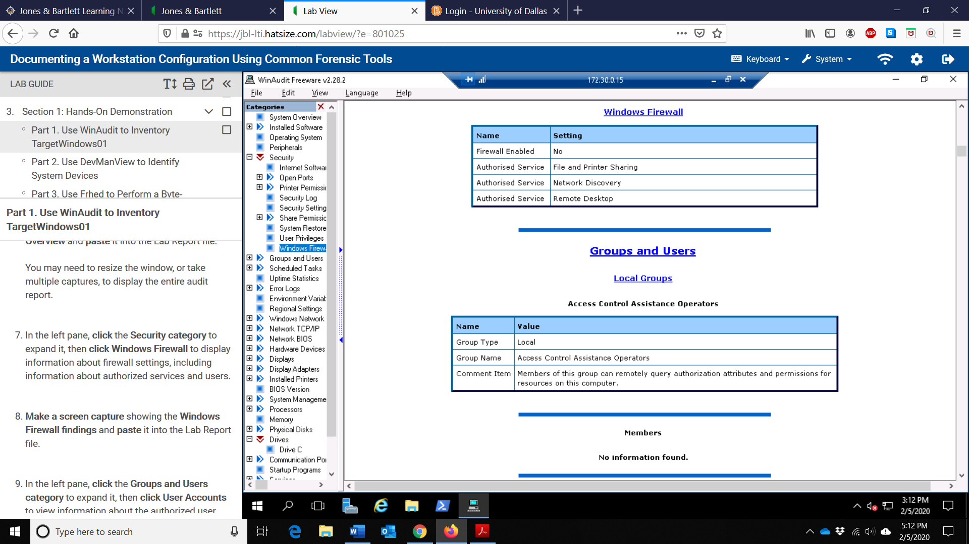

1. Make a screen capture of the User Accounts findings and paste it into the Lab Report file.

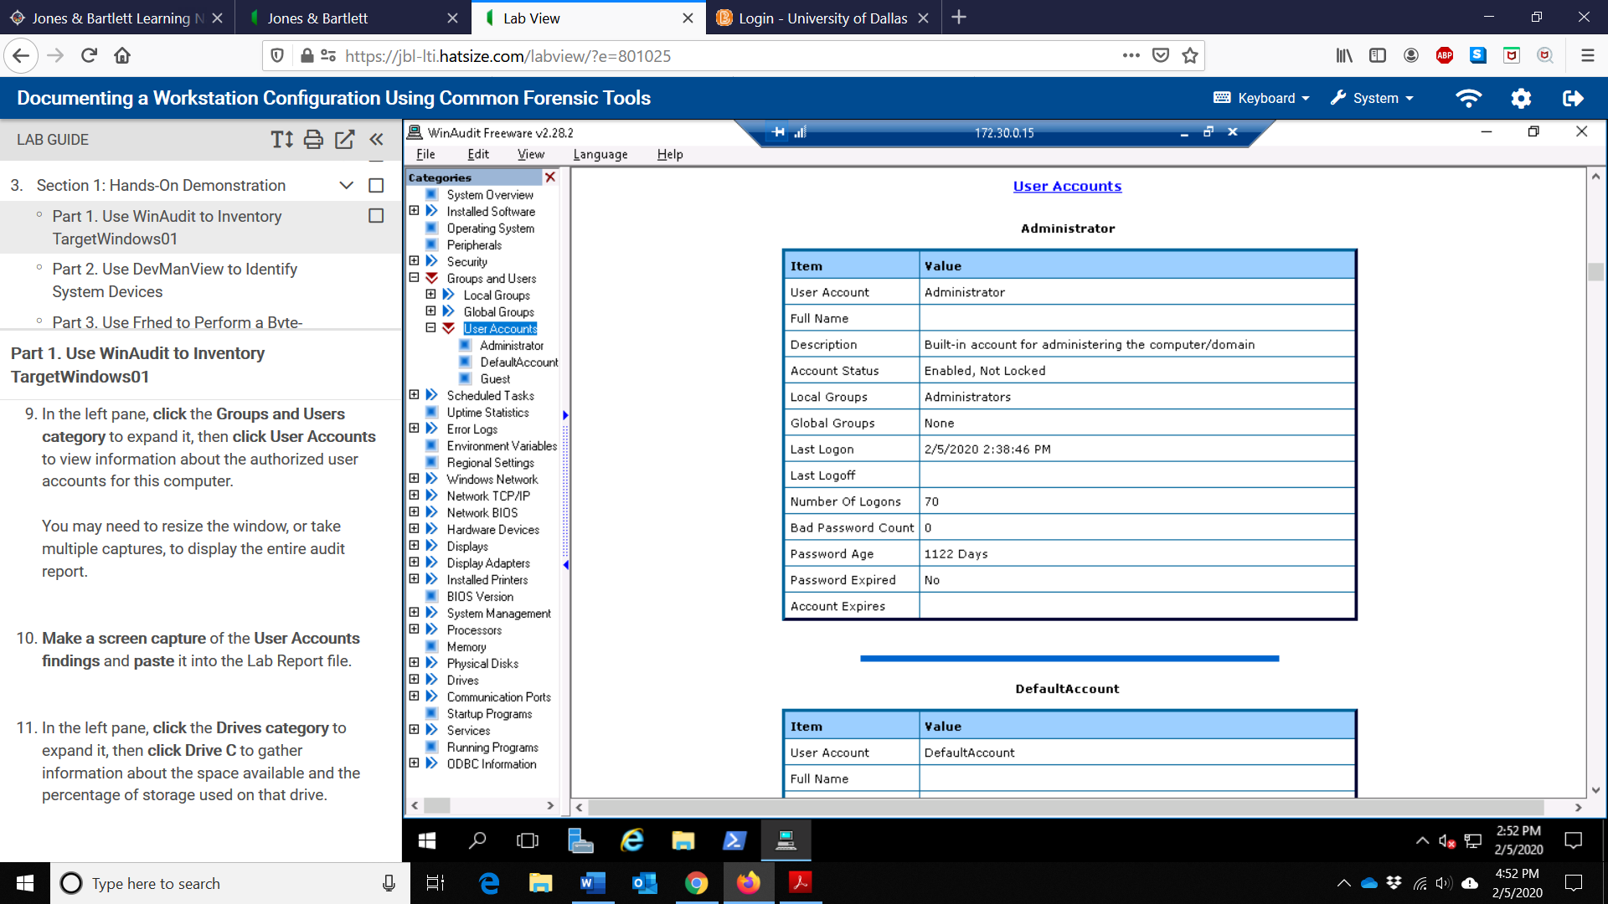

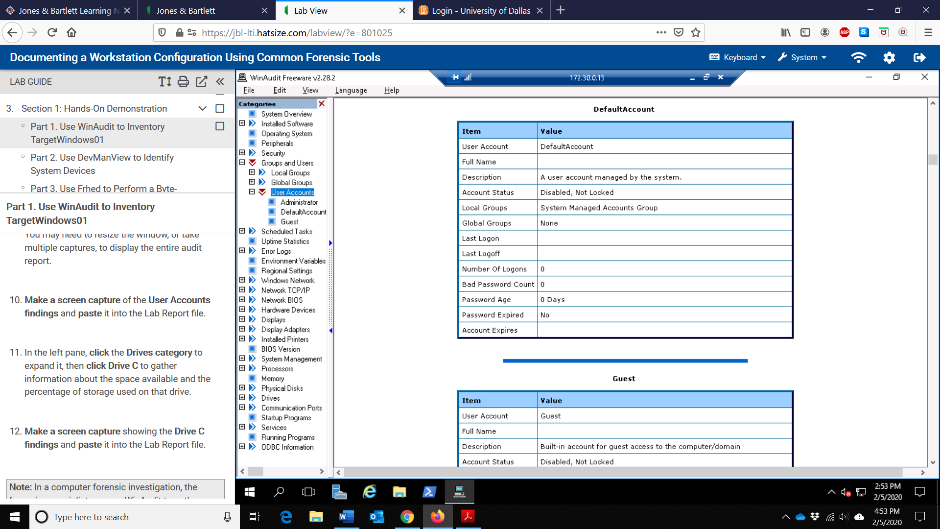

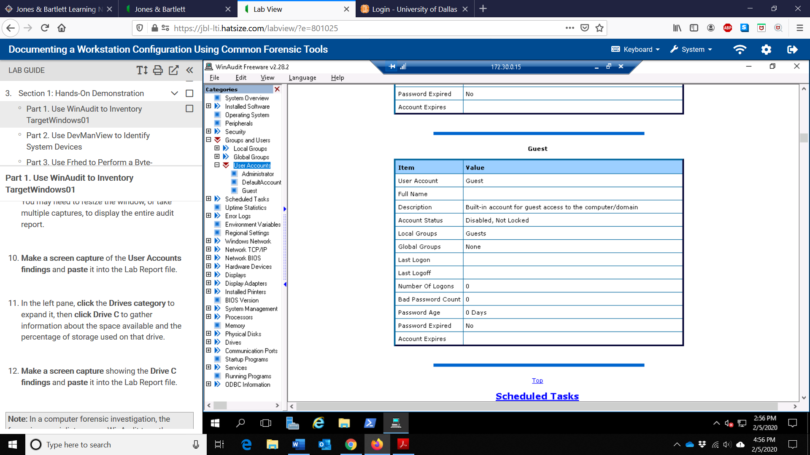

1. Make a screen capture showing the Drive C findings and paste it into the Lab Report file.

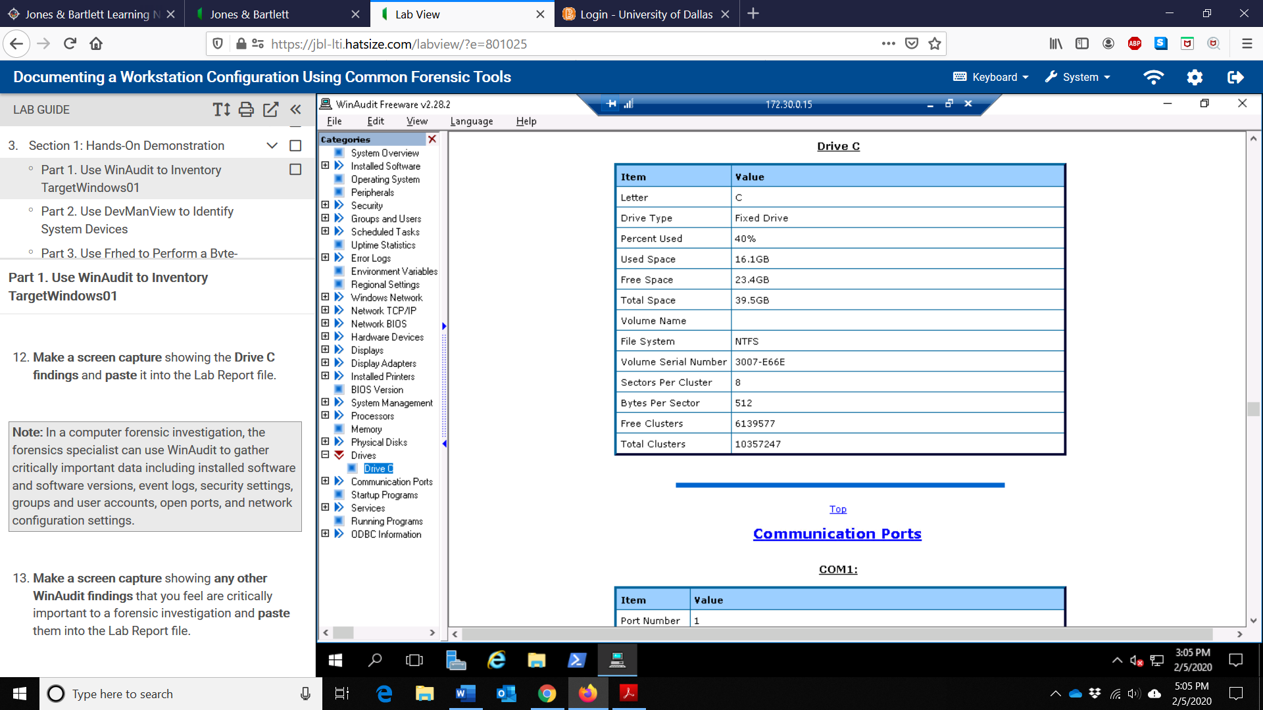

1. Make a screen capture showing any other WinAudit findings that you feel are critically important to a forensic investigation and paste them into the Lab Report file.

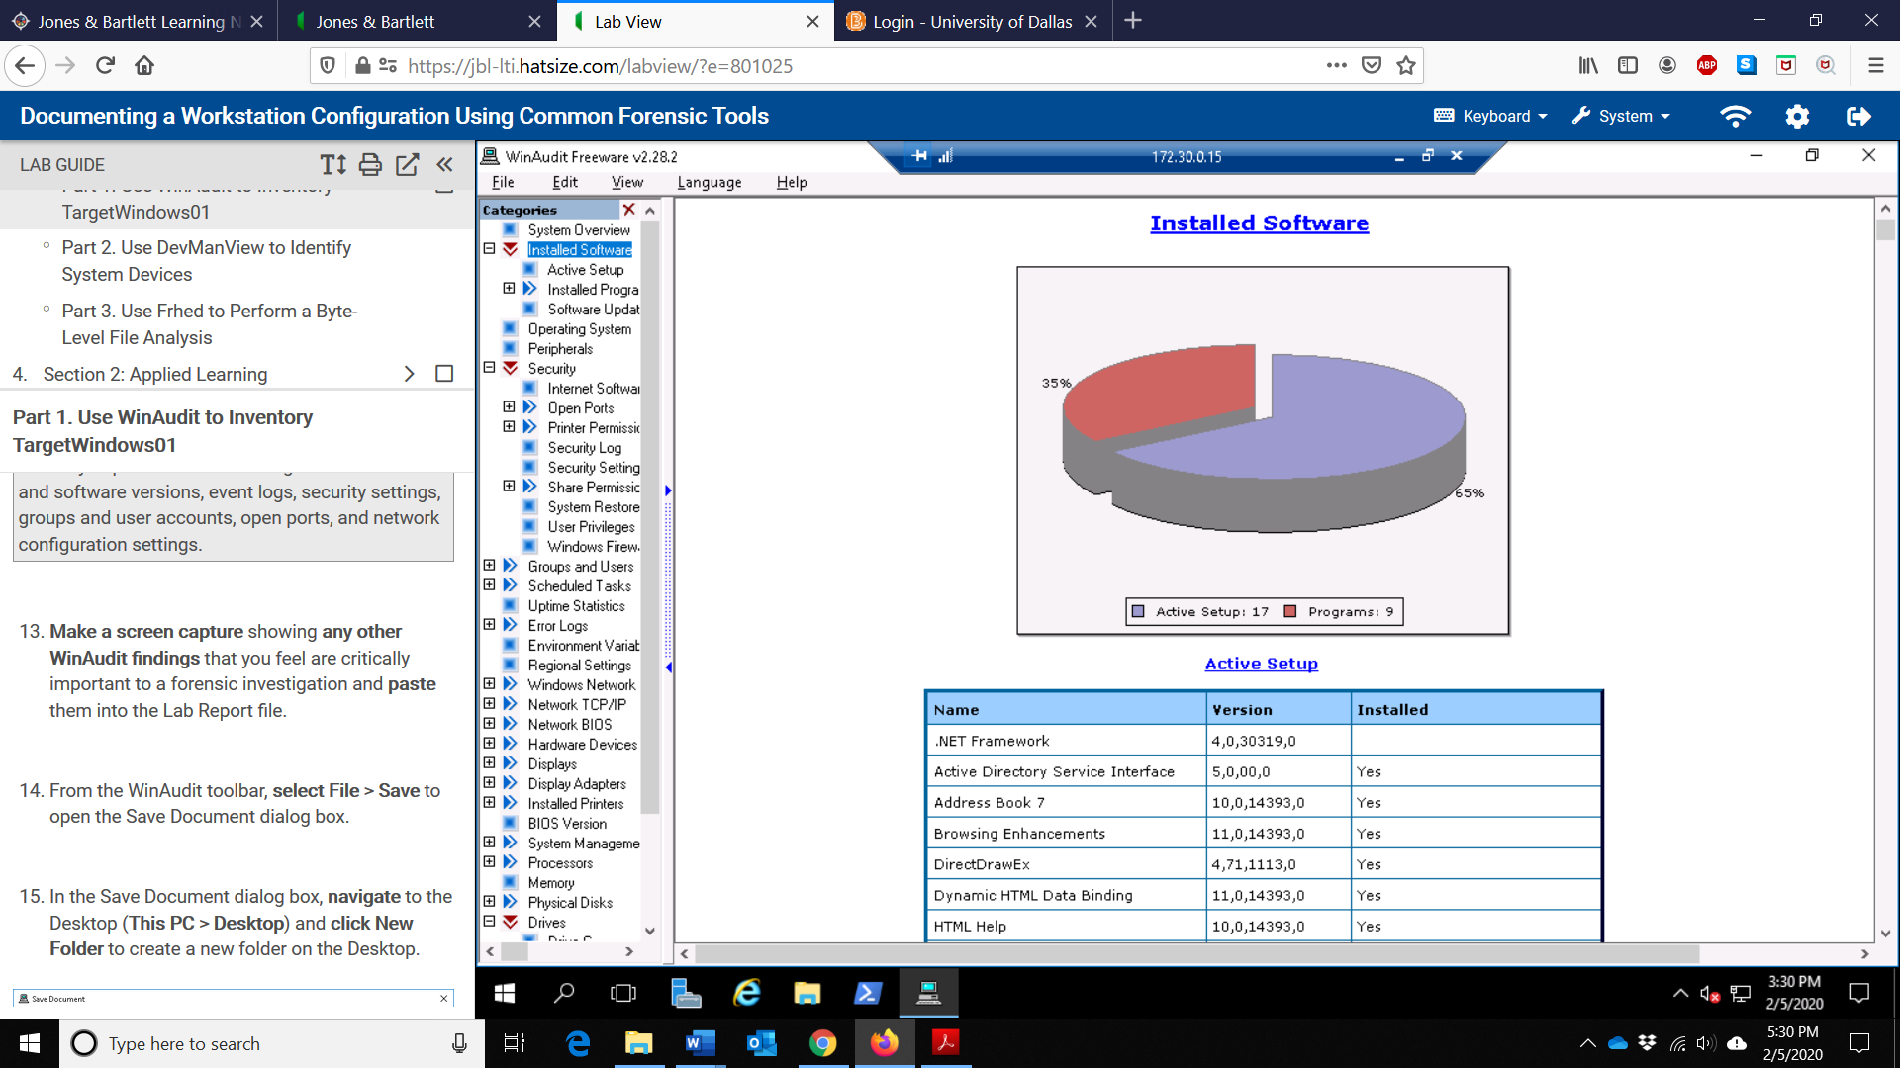

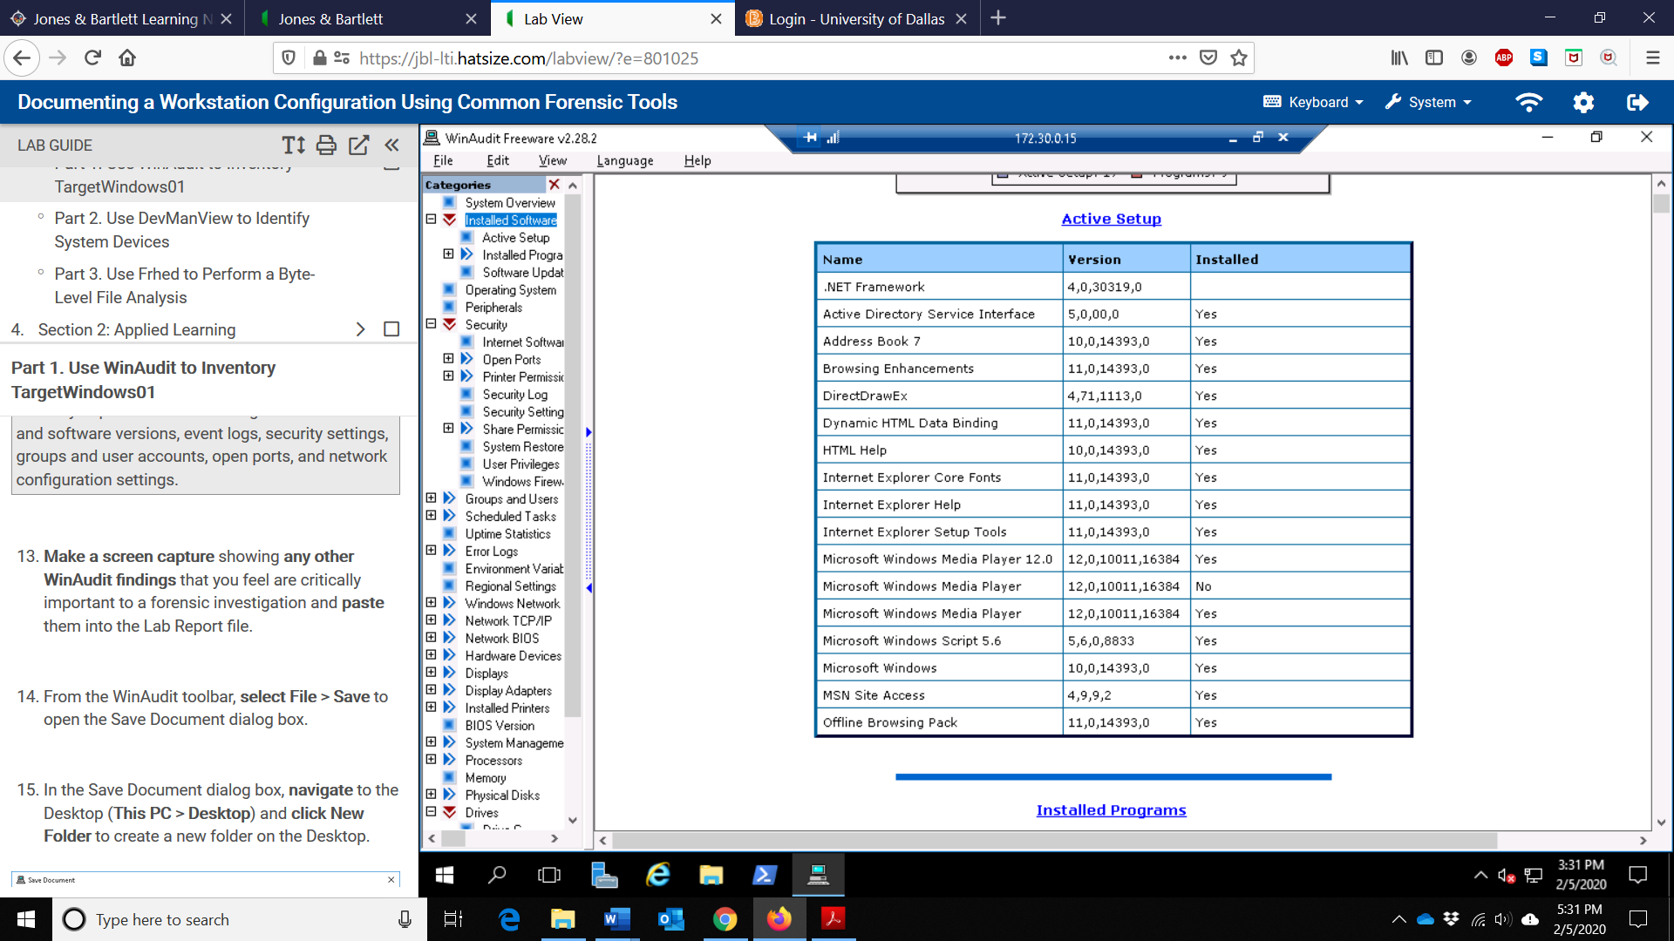

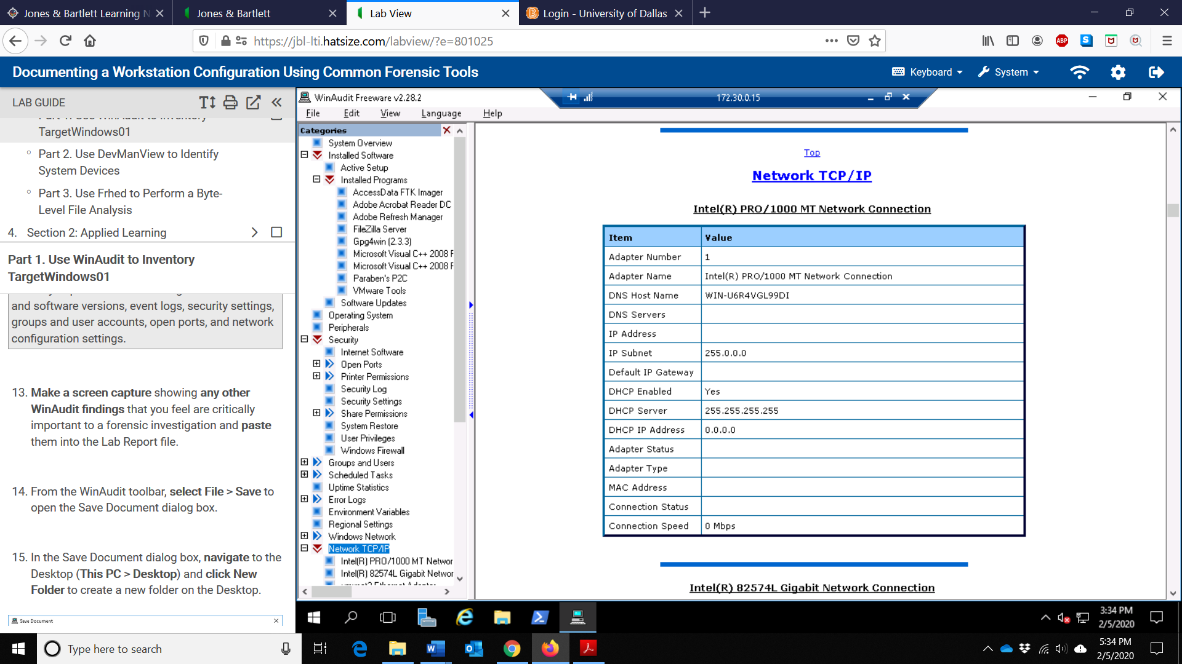

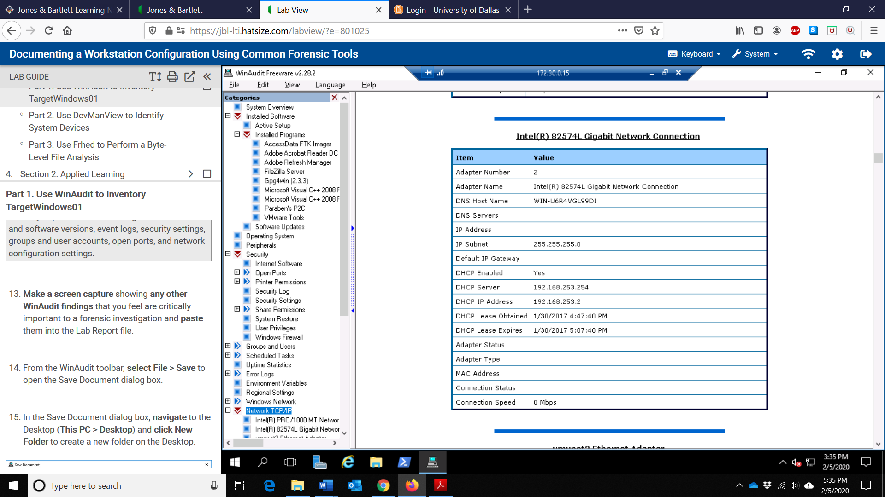

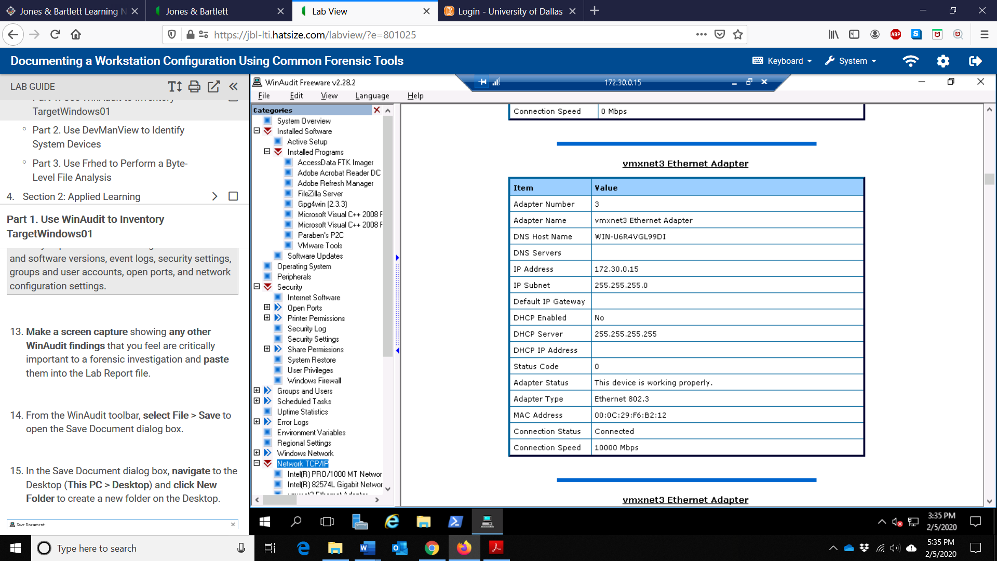

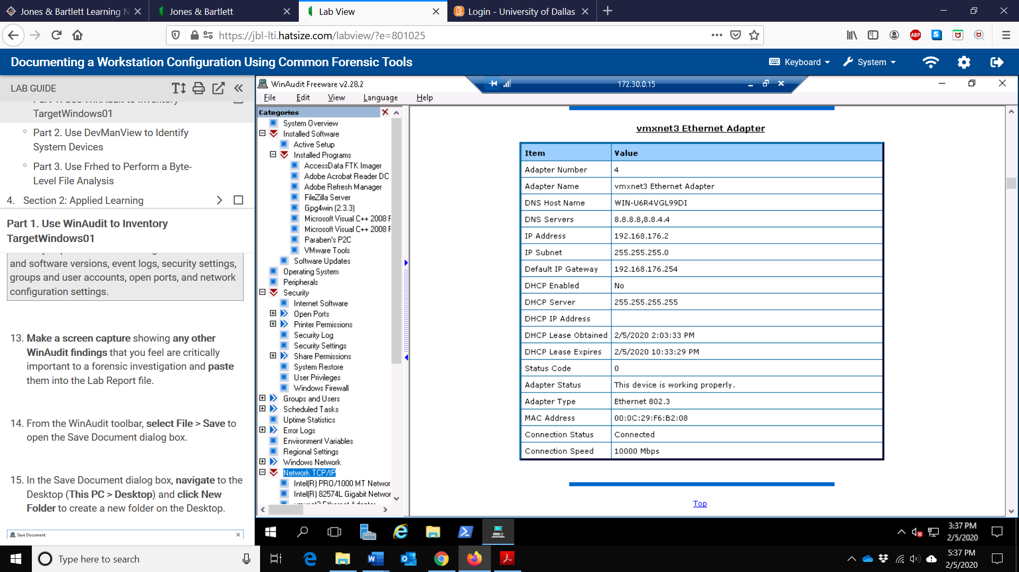

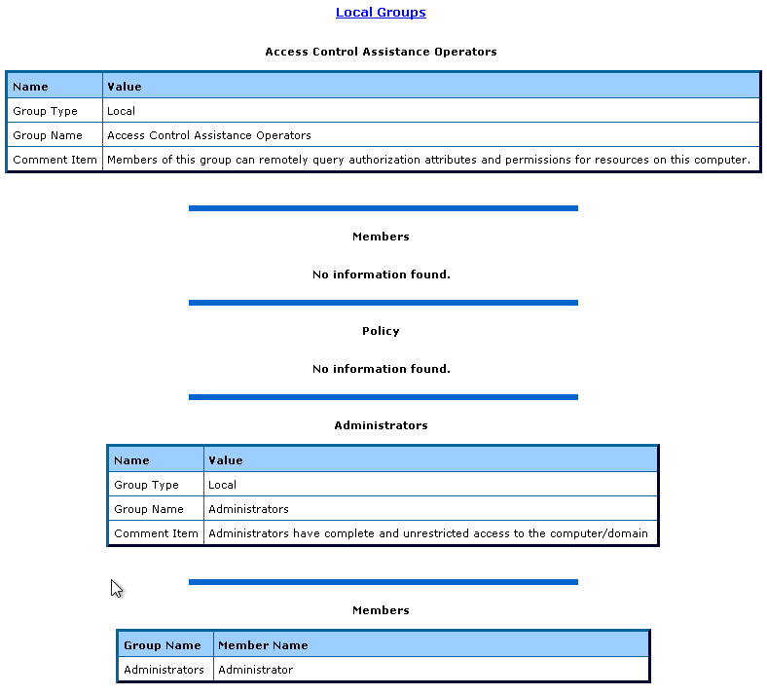

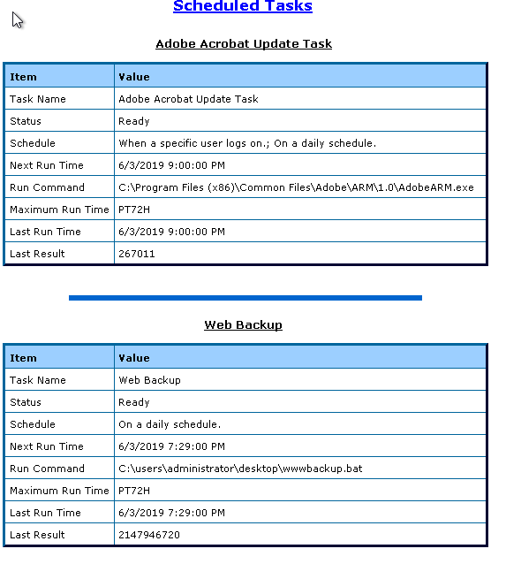

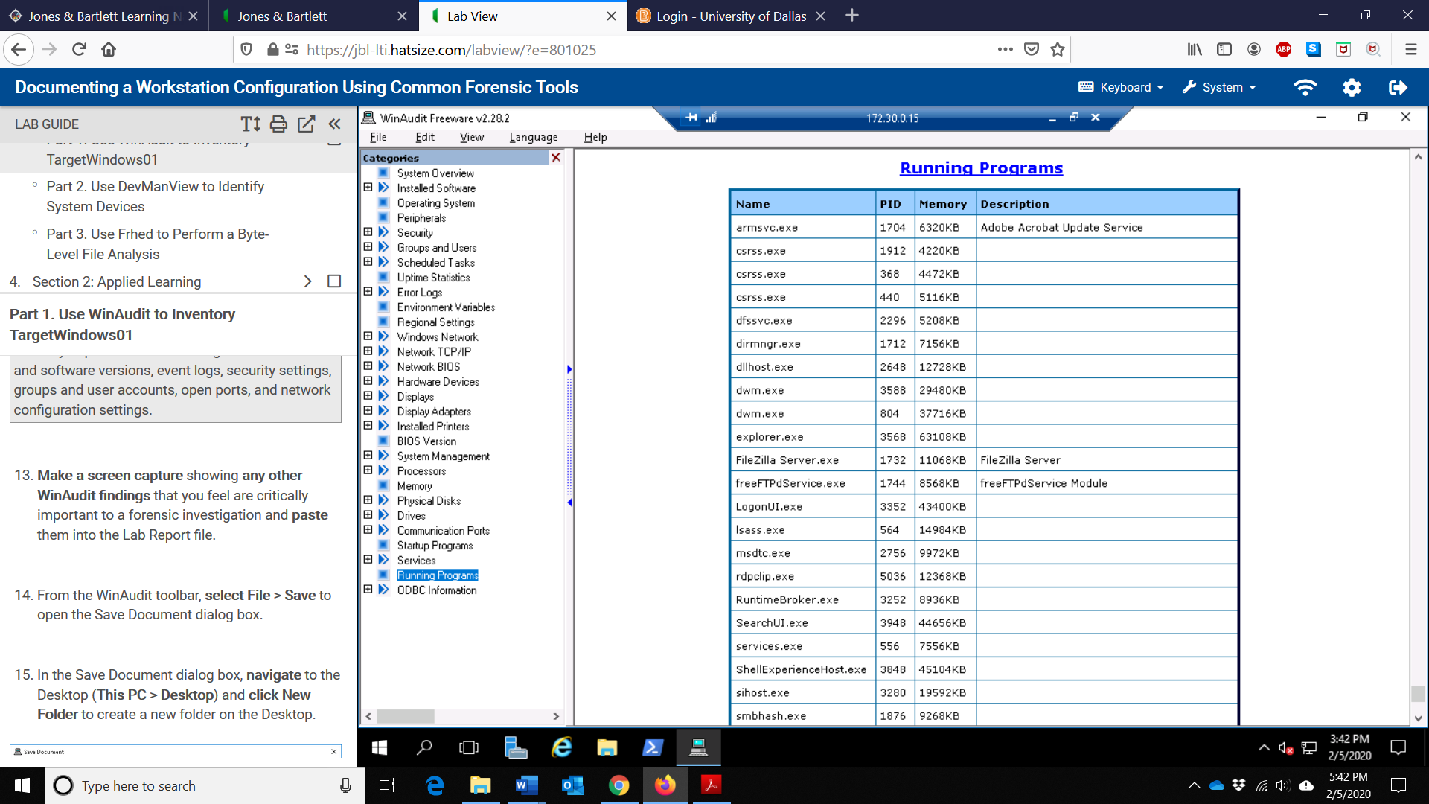

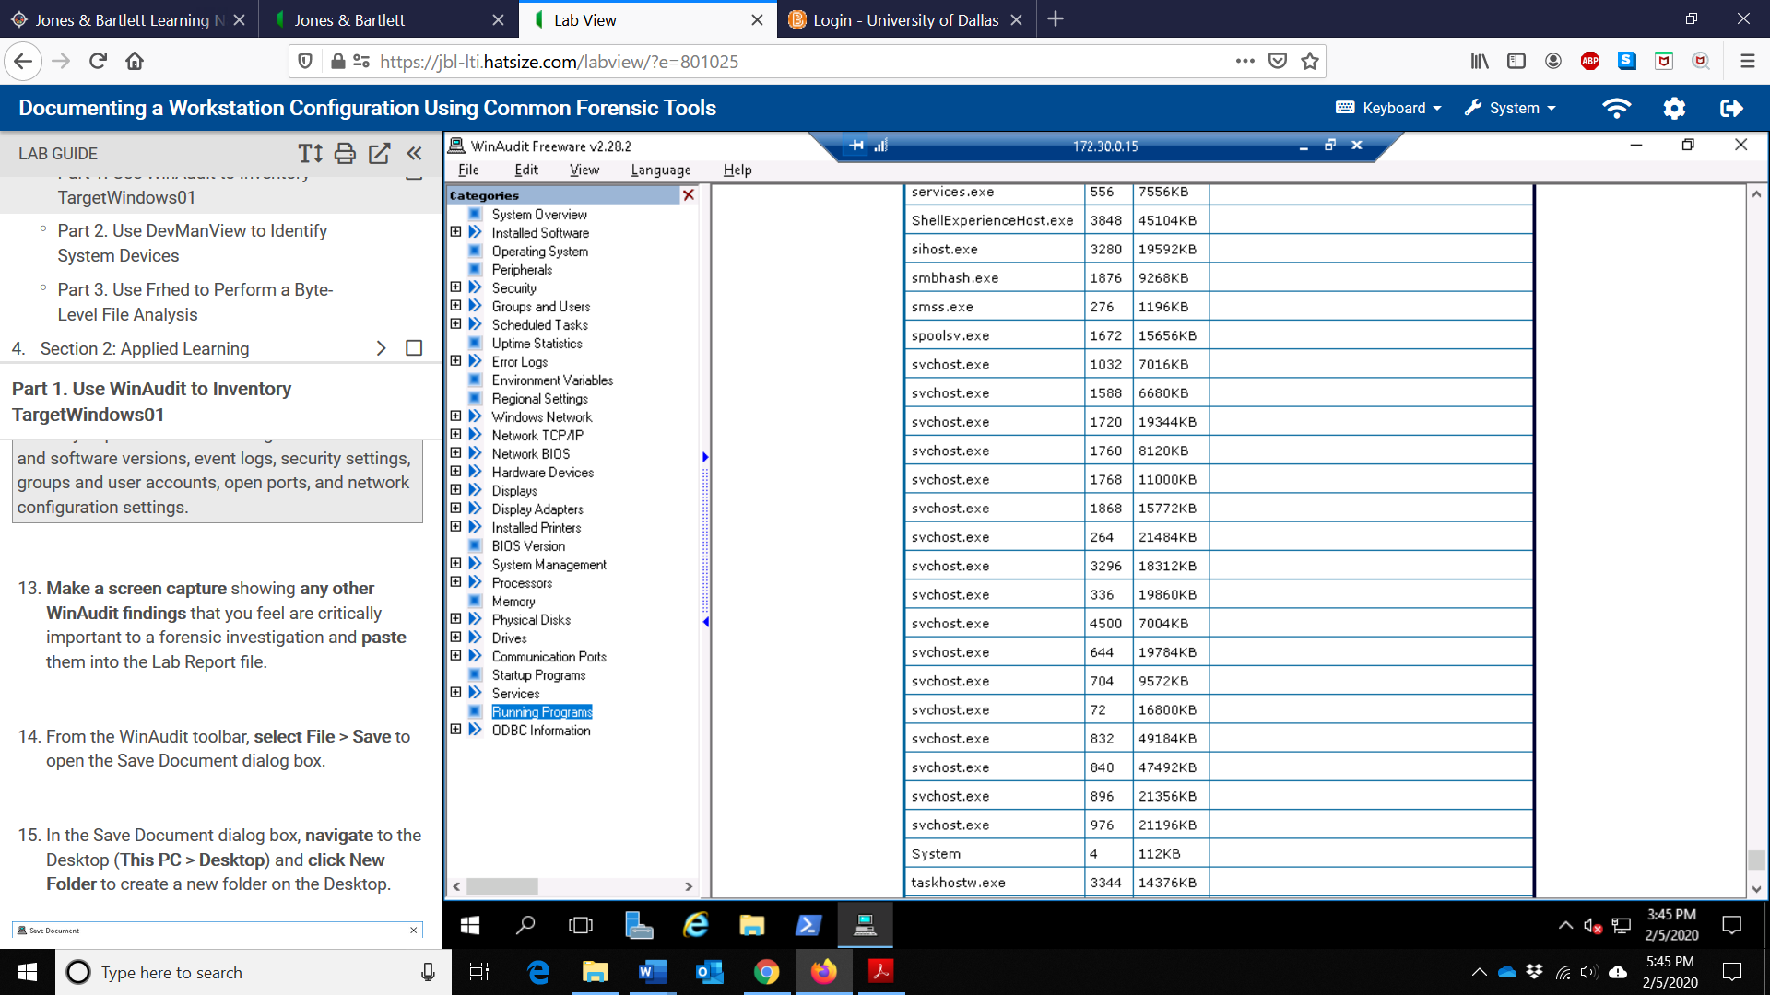

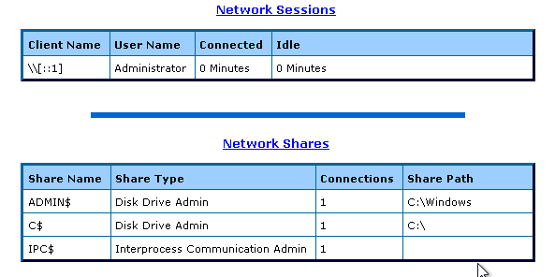

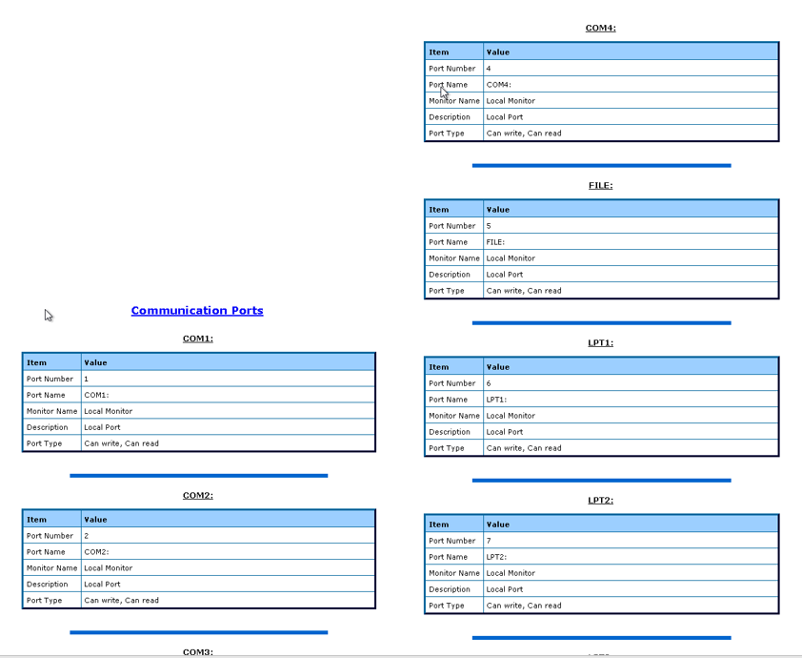

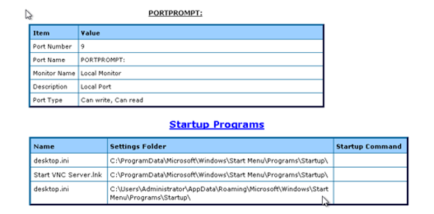

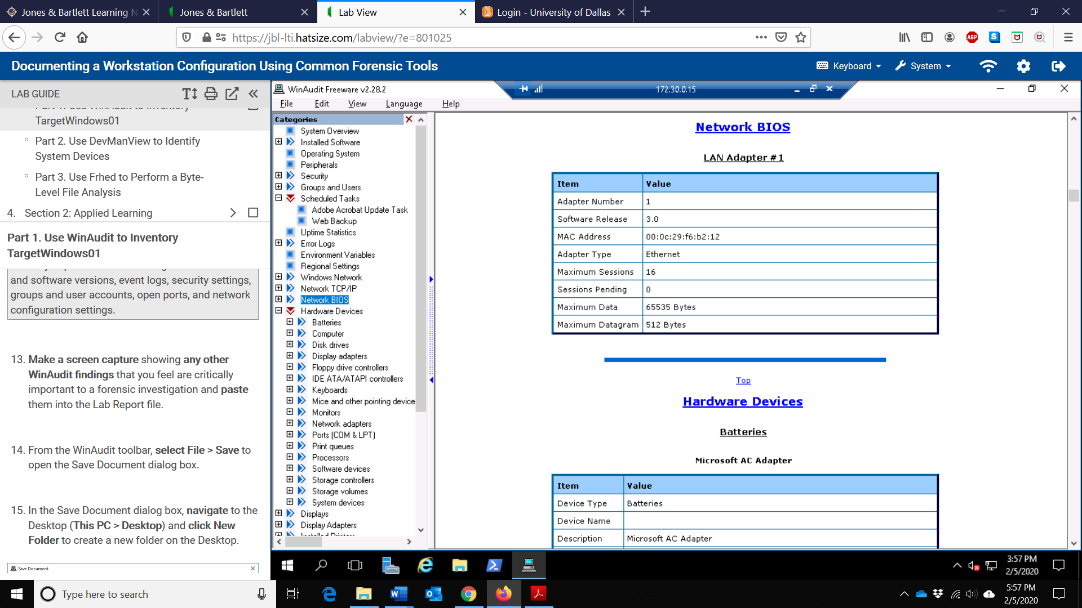

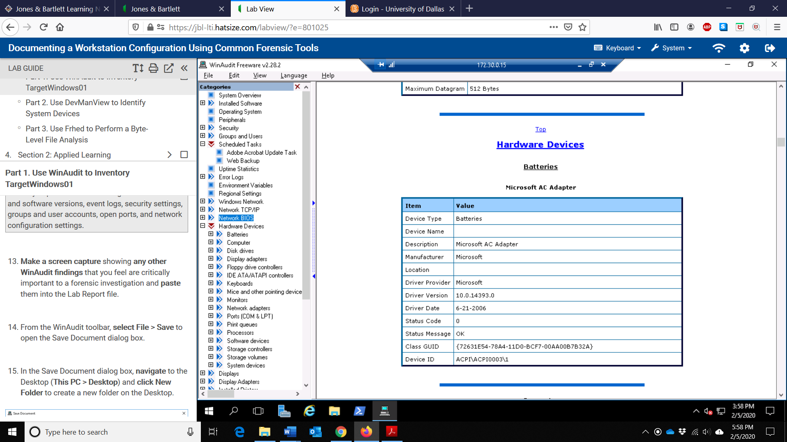

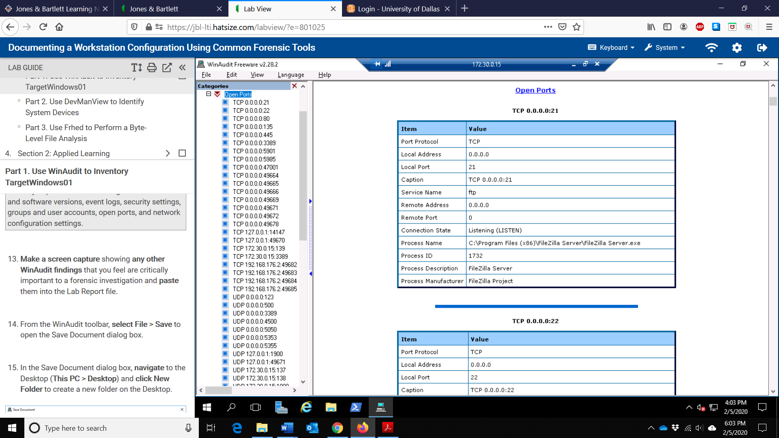

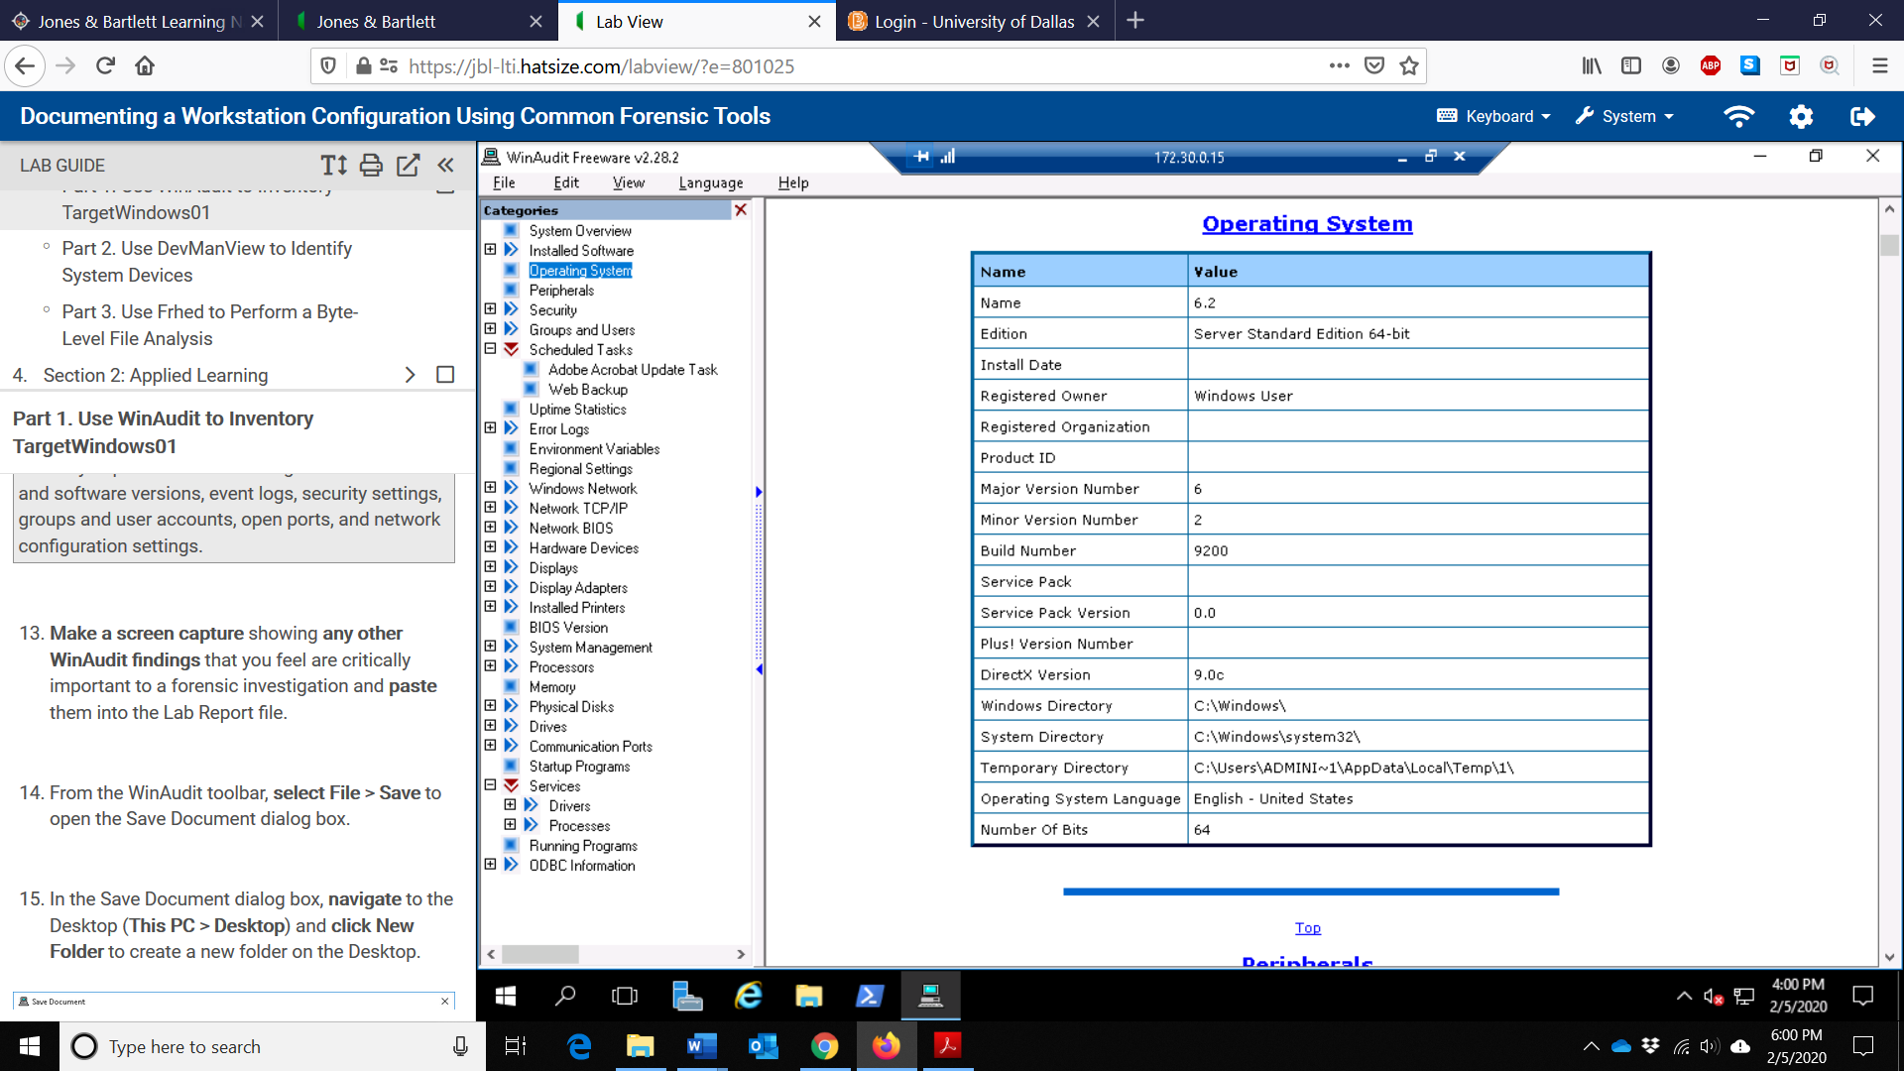

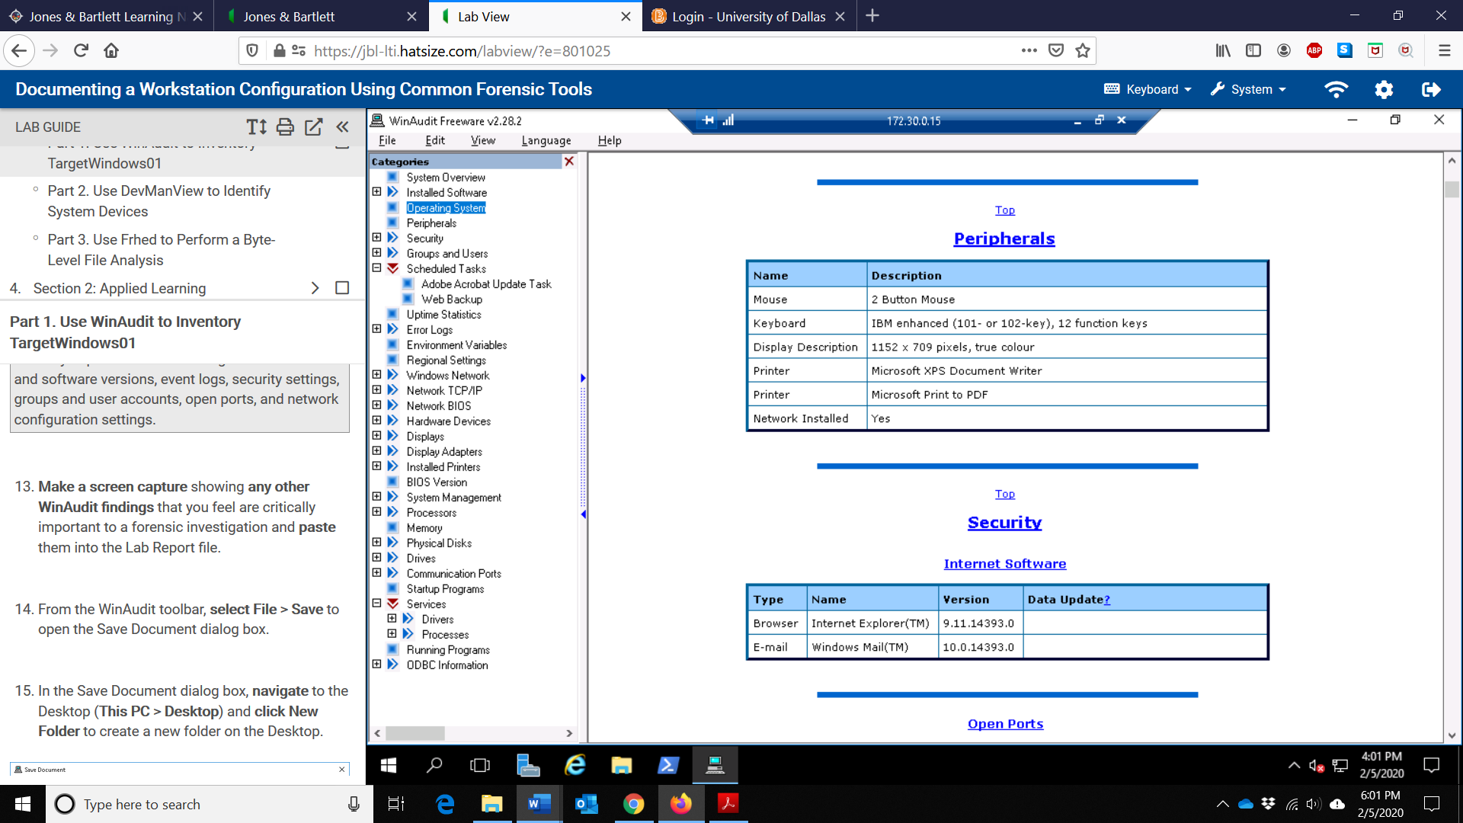

1. Make a screen capture showing the System CMOS/real time clock properties and paste it into the lab report file.

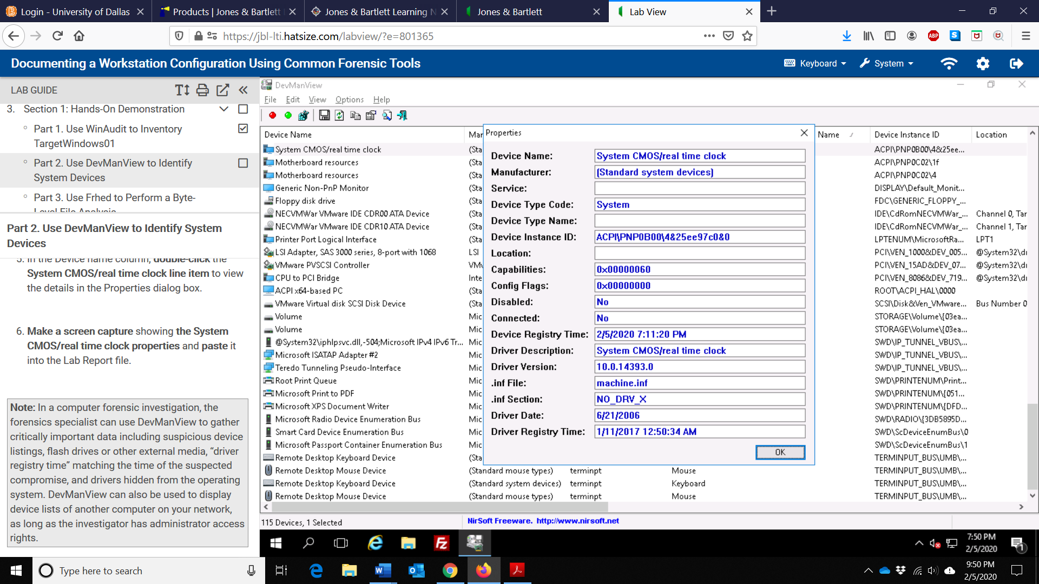

1. Make a screen capture showing the contents of the challenge.pdf file and paste it into the Lab Report file.

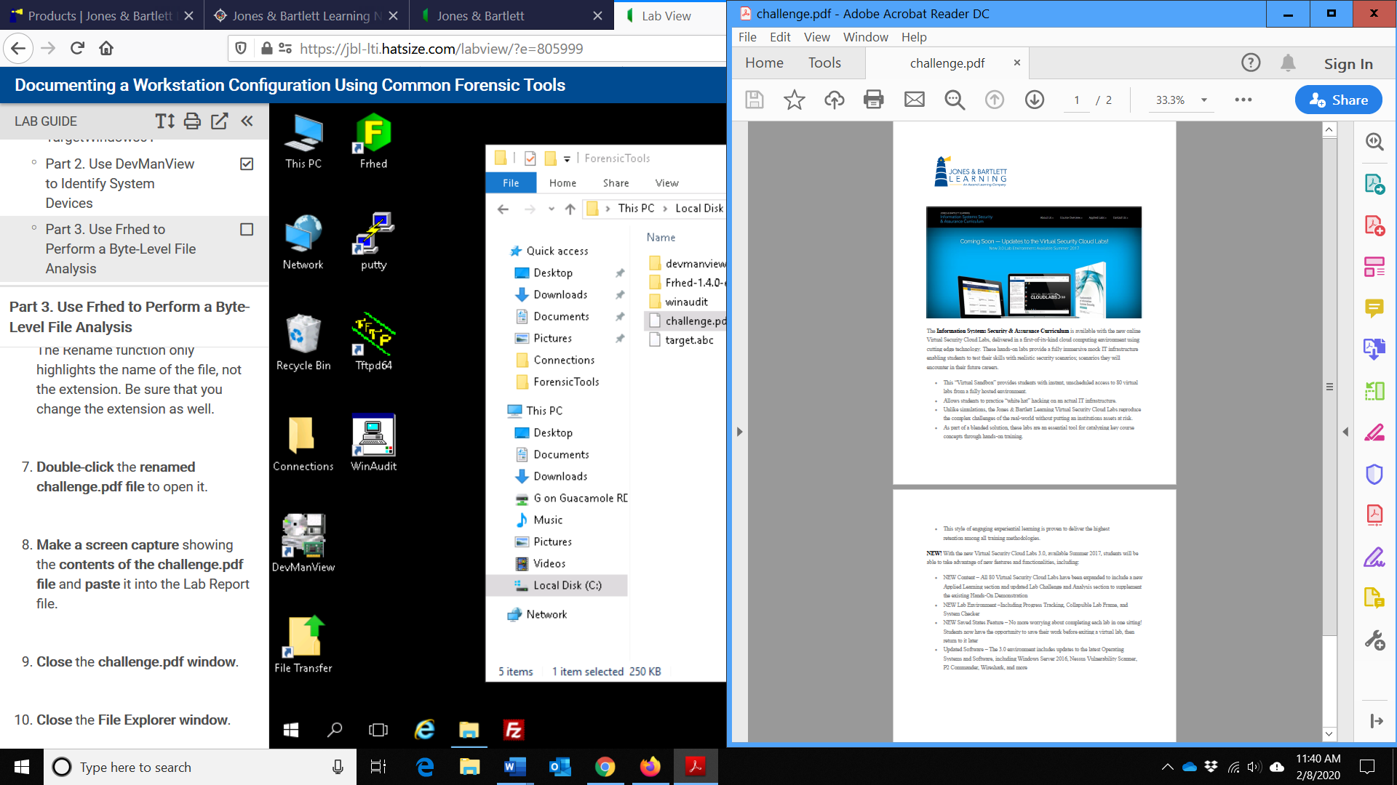

1. Make a screen capture showing the contents of the File properties dialog box and paste it into your Lab Report file.

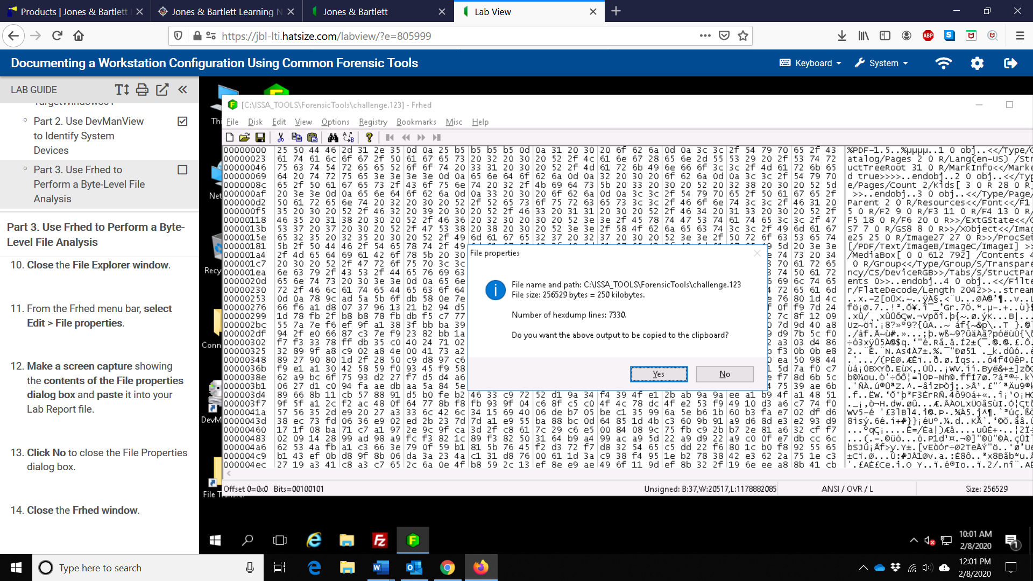

Any additional information as directed by the lab:

The number of connected devices identified by DevManView: 77

The total number of devices identified by DevManView: 115